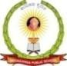

SRI SIDDAGANGA HIGHER PRIMARY SCHOOL
(Affiliated to CBSE New Delhi.)
1 Stage, II Phase, Chandra Layout, Bengaluru -72
MID TERM EXAMINATION, 2025-2026
SUBJECT: GENERAL SCIENCE
Class: IV Marks : 50 marks
Date: 03/09/ 25 Duration : 3 hrs
Name: ___ Roll No: __ Sec: ____

IDENTIFICATION | OBSERVATION | DISCOVERY FACTS | KNOWLEDGE | SKILLS | TOTAL
13 | 10 | 8 | 13 | 06 | 50
General instructions:
- Handwriting should be legible
- Avoid over writing

IDENTIFICATION
I. Identify the following pictures and answer the following questions.
1. Define aquatic animals. ( 1)
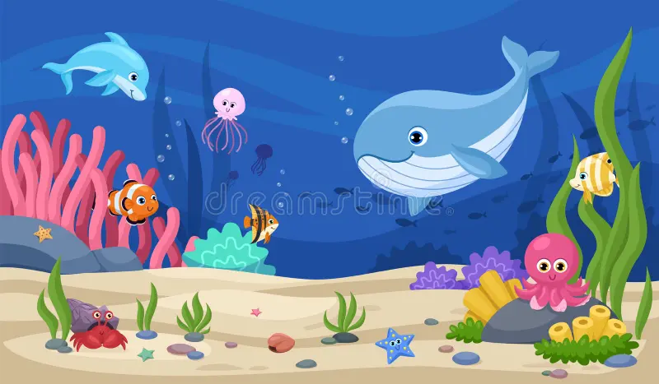 Ans._______________________________________________________
_____________________________________________________________________________.

2. a) Write any 2 functions of leaves? ( 2)


Ans. _______________________________________________

___________________________________________________

___________________________________________________.

b) How does stomata help the plants? (1)
Ans. _____________________________________________________________________

___________________________________________________________________________.

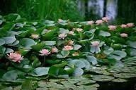
3. a) Define fixed plants? (2)
Ans. _______________________________________________________________________
___________________________________________________________________________.
b) what are insectivorous plants? (1)
Ans. _____________________________________________________________________

___________________________________________________________________________.
4. Define incubation. (1)
Ans. ______________________________________________________________________
____________________________________________________________________________.

II. Choose the correct option: ½ X5=2 ½
1. The stalk of the leaf is called _________________________.
a. petiole b. leaftip c. veins d. lamina
2. Vitamins are called as
a. energy giving foods b. body building foods c. protective foods d. fats
3. Animals that spend most of their time in the air are called ___________________________
a. Aerial b. arboreal c. amphibian d. terrestrial
4. which one of the following converts milk into curd _______________
a. yeast b. bacterium c. protozoan d. virus
5. Temporary set of teeth has only
a. 24 teeth b. 32 teeth c. 20 teeth d. 16 teeth
III. Name the following. ½ X 5=2 ½
1. The winter sleep by some animals is called______________________
2. Yello portion of the egg ____________________.
3. The chemical which help to digest the food _______________________.
4. The way of cooking puries and samosas _______________________.
5. The microbes that cause malaria and amoebic dysentery _____________________

OBSERVATION

I. Analogy. ½ X 5= 2 ½
1. Frog: Tadpole :: Grasshopper: ______________________
2. Incisors: Biting the food :: Pre-Molars : _____________________

3. Arboreal animal : Monkey :: Amphibians : ________________________
4. Egg laying : Hen :: Mammal:
5. Humans : Lungs :: Fish :
II. Match the following. ½ X 5= 2 ½
 | A |  | B
1. | Broad part of a leaf | a. | Cow
2. | Herbivore | b. | Tough material of teeth
3. | Body building food | c. | Lamina
4. | Dentine | d. | Chlorophyll
5. | Green pigment | e. | Proteins

III. Observe the pictures and answer the following question.
1. a) Name four stages in the life cycle of butterfly. (1)
Ans. _____________________________________________________________________

___________________________________________________________________________.

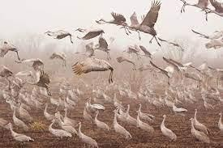
b) What is migration? (1)
Ans. _____________________________________________________________________

___________________________________________________________________________.

2. What are scavengers? Give any two examples. (2)
Ans. ________________________________________________________________________

_____________________________________________________________________________
_____________________________________________________________________________.
3. Define photosynthesis. (1)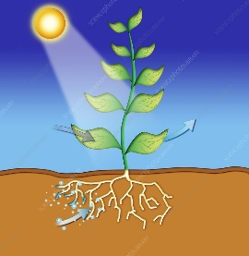 Ans. ______________________________________________________________
__ ___________________________________________________________________________
______________________________________________________________________________.
Discovery of Facts
1X2=2
I. Directions: the questions below, there are two statements marked as Assertion(A) and Reason(R).Read the statements and choose the correct option.
  - Both (A) and (R) are correct and (R) is the correct explanation of (A).
  - Both (A) and (R) are correct but (R) is not the correct explanation of (A).
  - Assertion(A) is true, but Reason (R)is false. (d)Assertion(A) is false, but Reason (R)is true.
    - Assertion(A): A balanced diet makes us healthy.
Reason(R): A balanced diet contains all the nutrients in an adequate amount.
Ans:_
_____________________________________________________________________________

    - Assertion(A): Birds have hollow bone and boat shaped body.
Reason(R): This adaptation help them to float on water.
Ans:

II. Read the given passage and answer the following questions: (2marks) The process of breaking down of food into a simple form that can be easily absorbed by the blood, is called digestion. Some organs of the digestive system together form a long tube like structure called the alimentary canal. It starts with the mouth and ends at the

anus. From the mouth, it leads to the food pipe, stomach, small intestine, large intestine and anus. Saliva makes the food moist and soft so that it easy to swallow. It has chemicals called enzymes in it which help to digest the starch present in the food.
1. What is meant by digestion?
_______________________________________________________________________________________________________
___________________________________________________________________________

2. Name the parts of human digestive system.

_________________________________________________________________________________________________________

____________________________________________________________________________

III. Give Reasons for the following. 1X4=4
- Mangroves grows in marshy areas.
______________________________________________________________________________
______________________________________________________________________________
______________________________________________________________________________
- Monkey and dolphin belong to the same category.
_____________________________________________________________________________
3. why do animals adopt themselves
____________________________________________________________________________________________________________
____________________________________________________________________________________________________________
____________________________________________________________________________________________________________
4. Dormouse and frog hibernate in burrows.
______________________________________________________________________________
______________________________________________________________________________
_______________________________________________________________________________

KNOWLEDGE
I. Answer the following questions:
1. What are insectivorous plants? Give 2 examples. (2)
______________________________________________________________________________
___________________________________________________________________________
___________________________________________________________________________
2. a) List the 5 methods of food preservation. (2)
__________________________________________________________________________________________________________
__________________________________________________________________________________________________________
___________________________________________________________________________________________________________
___________________________________________________________________________________________________________
____________________________________________________________________________
____________________________________________________________________________
___________________________________________________________________________.
b) What are microbes. (1)
_____________________________________________________________________________
_____________________________________________________________________________
3. How do animals take care of their young ones? (2)

__________________________________________________________________________________________________________________________________________________________________________________________________________________________________________________________________________________________________________________________________________________________________________________________________________________________________________________________________________________________________________________________________________________

4. a) what is meant by digestion of food. (2)

_____________________________________________________________________________________________________________

b) How many permanent teeth are there in our mouth. (1)

5. Name the four types of teeth. (1)

6. Explain the phenomenon of camouflage. (2)

SKILL
1. Label the digestive system. (2)

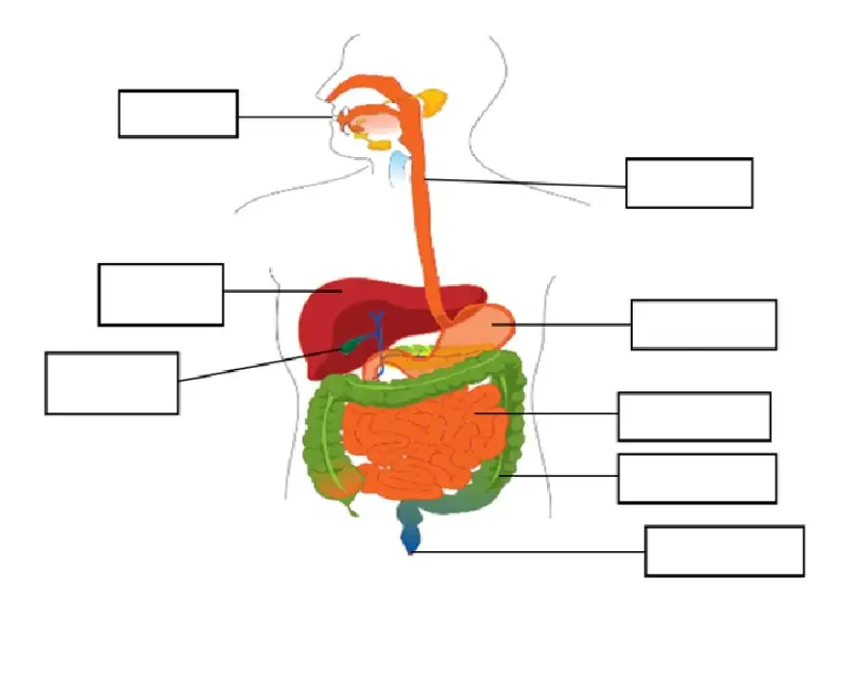

2. Draw any two neat diagram of fixed plants. (2)

3. Draw a neat labeled diagram of life cycle of frog. (2)

